Implementation and maintenance?: the act of using alternative solution or developed solution and providing support to a system

**Design**: the act of developing alternative solution to a problem

**Analysis is: What is programming analysis?**

In computer science, program analysis is **the process of automatically analyzing the behavior of computer programs regarding a property** such as correctness, robustness, safety and liveness. Program analysis focuses on two major areas: program optimization and program correctness

**Low-level languages** are languages that sit close to the computer's instruction set. An instruction set is the set of instructions that the processor understands. Two types of low-level language are: **machine code**

**high-level language**: a computer programming language that resembles natural language or mathematical notation and is designed to reflect the requirements of a problem

Python programming Language: is a highlevel programming language that is easy to learn and code with, it is used for variety of things such as GUI development and advanced system programming

**Key notes about python**

1. it uses lines to complete command
2. Python relies on indentation
3. Comment start with a # symbol
4. Python auto select data type based on value assigned to a variable.

**SYNTAX ERRO:** Syntax error is an error in the syntax of a sequence of characters or tokens that is intended to be written in compile time

Pseudocode: it is the representation of an algorithm

**Problem Solving**

Thus, **problem solving** is the process of defining a problem, determining the cause of the problem, identifying, prioritizing and providing alternative solution.

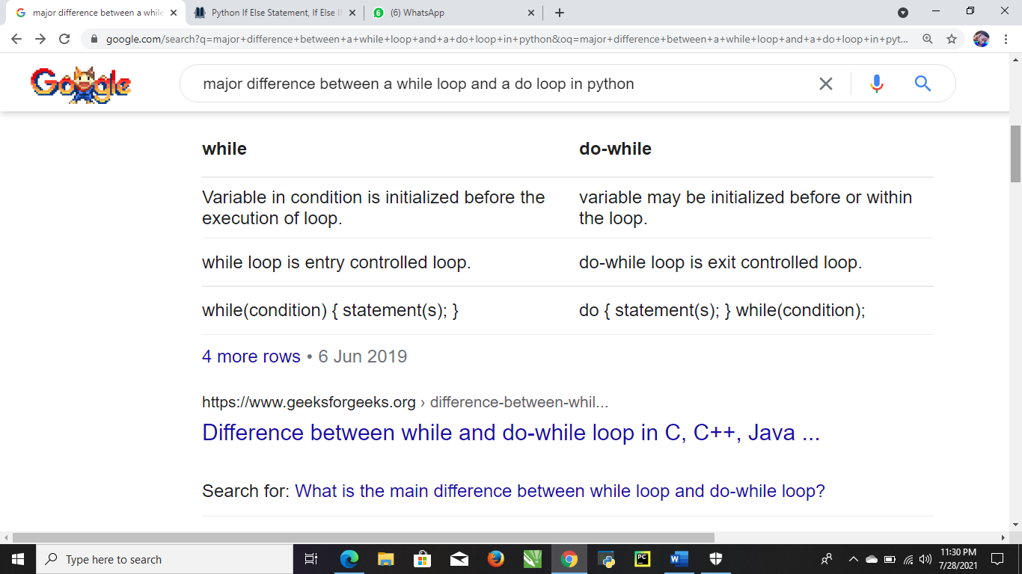

**Steps Involved in problem Solving**

Step 1: Identifying and define the problem

* State the problem as clearly as possible

Step 2: Generate Possible solutions

* List all possible solutions, don’t worry about the quality of solutions at this stage

Step 3: Evaluate alternatives

* Removing less desirable or unreasonable solutions
* Evaluate the remaining solutions in terms of their advantages

Step 4: Decide on Solution:

* Specify how the solution will be implemented

Step 5: Implement the solution

**Control statement:** Control statement enables us to specify the flow of the program control i.e the order in which the instructions in a program must be executed

Types of control statement

1. Conditional/selective statement: Allows you to control the execution flow of the program depending on the condition
2. Iterations/loop statement: cause statement to be executed zero or more times, subject to some loop termination criteria
3. Jump statement: causes an unconditional jump to another statement elsewhere in the code.

**CRITERIAS FOR MEASURING THE EFFICIENCY OF AN ALGORITH**

1. Time complexity: is a function describing the amount of time an algorithm takes in terms of the amount of input to the algorithm
2. Space complexity: is a function describing the amount memory (space) an algorithm takes in terms of the amount of input to the algorithm

## **Characteristics of an algorithm:**

**1). Input:** An algorithm must have either 0 or more inputs.  
2). Output: An algorithm should have 1 or more desired output.  
**3). Unambiguous:** Every Algorithm should be unambiguous and clear. It means that it’s every step, and input/output should be clear and must have only one meaning.  
**4). Feasibility:** Algorithm should be feasible with the available resource.  
**5). Finiteness:** Algorithm should be terminated after a finite number of steps.  
**6). Independent:** Algorithm should have a step-by-step direction of each level, which is independent of programming language.

A while loop is used to execute a block of statement repeatedly until a given condition is satisfied

A do while: is a flow statement that execute a block of code at least once and then either repeatedly execute a block or stops executing it depending on the given boolean condition

Repetition: is the process of looping or repeating sections of a computer program

A Variable is a container for a particular type of datanb

# 

What is a while loop in Python?

In Python, While Loops is **used to execute a block of statements repeatedly until a given condition is satisfied**. And when the condition becomes false, the line immediately after the loop in the program is executed. While loop falls under the category of indefinite iteration.14 May 2021

A do while loop: is a control flow statement that a execute a block of code at least once and then either repeatedly execute a block or stops executing it depending on the given Boolean condition